Top 10 Digital Marketing Agencies in Dubai for Exceptional Results in 2025
Dubai has been through tremendous change in the use of technology in the last few years and companies in this city are embracing the active use of digital marketing tools to achieve their objectives. In the fast-growing digital marketing space, businesses must work with the right Digital Marketing Agency in Dubai with the necessary skills, knowledge, and capacity to produce outstanding results. This blog shall help you make the right decision when it comes to choosing a good agency in the future and what are the 10 best digital marketing agencies in Dubai for 2025.

Criteria for Selecting Top 10 Digital Marketing Agencies in Dubai:
It was important to determine criteria that help you define successful and well-known digital marketing agencies based in Dubai. Here are some factors that we consider while preparing the list of top 10 Digital Marketing Agencies in Dubai:

Experience and Expertise:
Lacking the ability to objectively compare agencies based on similar project specialties, the agency must rely on determining which company has been in the industry longer or which one’s specialization is a closer match.

Client Portfolio and Case Studies:
A great number of clients registered in the agency’s database and tremendous examples of successful cases can help to shed light upon the agency’s strengths and possible advantages for new clients.

Industry Reputation:
The reputation of the agencies can be created through awards, reviews, and ratings from a number of valuable sites including Clutch, GoodFirms, and The Drum.

Innovative Strategies:
Agency’s awareness of certain trends, technology, and creativity in their marketing styles sets those that remain relevant in the market.

Customer Service and Communication:
Responsiveness and clarity of communication with clients and the ability to create and develop a business-like and friendly relationship are the keys in today’s business world.

Results-Oriented Approach:
The choice of analyses as well as the nature of focusing on the quantifiable results as the key characteristics play a major role in this evaluation.

Top 10 Digital Marketing Agencies in Dubai:
The following is the list of the most popular and top 10 digital marketing agencies in Dubai.

1-Three Angle Marketing (TAM):
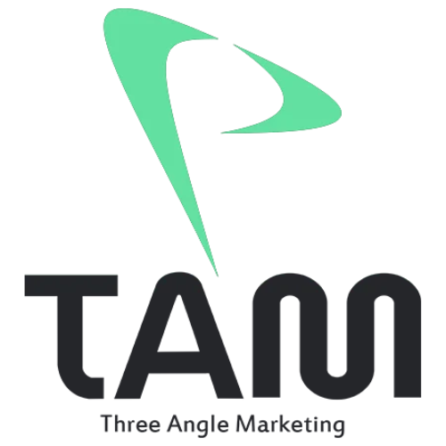
Three Angle Marketing, short for TAM, is an independent digital marketing agency Dubai famous for its innovative approach. TAM is a company that mainly offers services and due to the fine services, it has assisted many companies to register outstanding success in their campaigns. Some of its specialized services are social media marketing, Branding, Video Production, Web Development & Design and search engine optimization. By integrating quantitative analysis with creativity, TAM has always posted proven performance for its clients.

2-SEO Tech Experts LLC:

SEO Tech Experts LLC is one of the best companies providing SEO services in Dubai that specializes in SEO services offered and some of the significant accomplishments in enhancing the position of clients. The agency is proud of the numerous successful projects in terms of increasing the client’s rankings and organic traffic. Through using the newest technologies in the field of SEO and search engine marketing, SEO Tech Experts guarantee websites of their customers are placed in upper positions on the pages of search engines, which makes them more attractive to potential buyers.

3-Digital Dot:
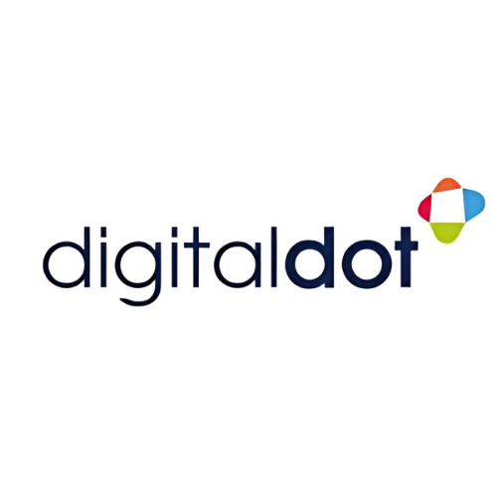
Digital Dot is a full-service Digital Marketing Company Dubai that provides many services. They offer almost all the services that clients can expect - Social Media Marketing, Search Engine Optimization, Web Development, and Conversion Rate Optimization. After great importance has been placed on the innovation of this program, Digital Dot of course guarantees a 100% success rate and customer satisfaction. Digital Dot is a group of specialists who are constantly regarding the tendencies in the field of digital marketing and delivering effective solutions for other companies' success.

4-Pearl Lemon:

Pearl Lemon is an agency, which primarily operates in the lead generation sphere and uses innovative tactics to define the customer’s demand. Employing professional marketers, they utilize sophisticated strategies taking into account imperative factors helping clients reach a higher conversion rate, and providing constant quality results. As a result of its streamlined approach to the generation of superior quality leads, Pearl Lemon has earned an excellent reputation in the Dubai market.

5-LUMINA:
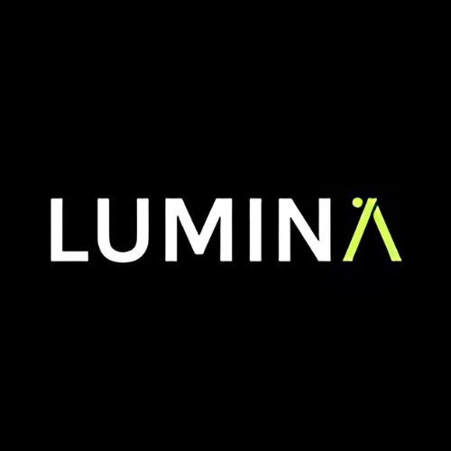
LUMINA has ten years of experience in creative marketing services and is particularly skilled at creating engaging brand narratives. LUMINA's team of creatives has both strategy and the marketing creativity needed to navigate the congested world wide web on behalf of their brands. Based on effective storytelling, LUMINA designs successful campaigns that not only increase brand awareness but also help create an emotional bond between a brand and consumers.

6-EDS FZE:

EDS FZE has vast experience in its operation in digital development and analytics-based strategies. The highly skilled personnel of EDS FZE in development and marketing effectively collaborate with clients to design bespoke solutions suited to unique needs. The innovative strategies of EDS FZE reflect the data-driven approach that it uses to guarantee that its strategies yield tangible and sustainable results for business growth.

Additionally, EDS FZE has high levels of expertise in areas of digital development and operation based on the analysis of performance indicators.

7-Digital Marketing Dubai (DMD) Services:
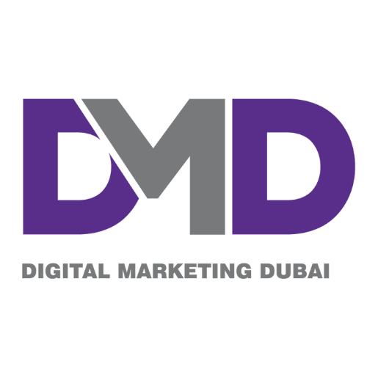
DMD Services is a digital marketing agency with specialized knowledge in entire strategies vdin marketing. Their team analyses their clients’ online profiles and since then they have offered all major types of digital marketing services, from web design to development and search engine optimization to social media marketing. With a tremendous focus on quantifiable outcomes, DMD Services guarantees that all its clients’ investments are well-utilized and provide consistent ROI.

8-Glimpse Digital Agency:

Glimpse Digital Agency is best known for its creativity and effective selling techniques with clients and always crafts unique campaigns and strategies for its clients. It shows that the agency has always been abreast with market trends, offering new and interesting campaign packages that will help attract and maintain the needed customers. Due to the increased focus on client interactions, Glimpse Digital Agency guarantees their clients’ brands stay unique, and noticeable in the digital realm.

9-Emirates Graphic:
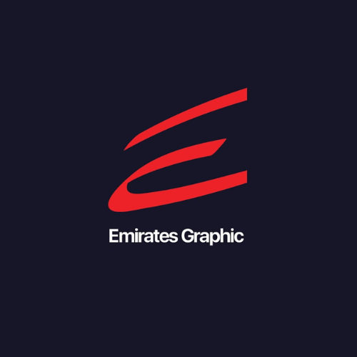
Emirates Graphic has rich expertise in developing mobile applications for e-commerce platforms, and crafting lead-generation strategies to generate better results. Their team of professional designers and marketers develops attractive graphics and relevant content that impress people and develop brand recognition. Using striking visuals alongside marketing, Emirates Graphic helps its clients have the greatest return on investment and brand exposure.

10-Prism Digital Marketing:
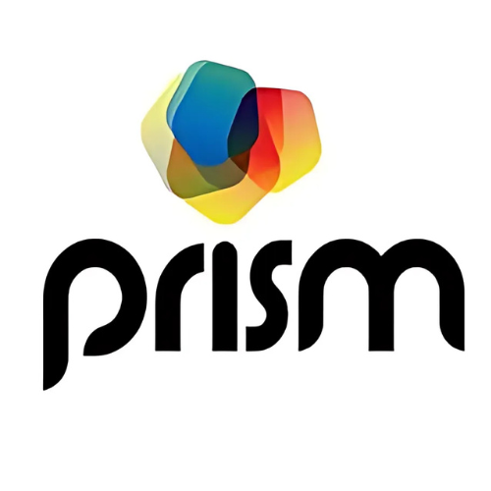
Prism Digital Marketing is highly respected for producing high-quality strategies and specialized analysis. Their team of industry specialists specializes in trend analysis, audience segmentation and creating successful communications campaigns with tangible outcomes. Being a leading digital marketing company in Dubai, Prism Digital Marketing strives to ensure that all the brands constantly update their presence on the internet so that they can compete well with other firms.

How to Choose the Right Agency in Dubai

Assess Your Needs:

Choosing the right digital marketing agency in Dubai begins with determining the precise marketing objectives and expenditures you intend to make. This way you realize your needs and get connected with the best agency, in your contest and with reference to the financial bond, that offers you the best results in the best possible way.

Tip:
- Defining or recognizing special goals or objectives and its effective marketing budget.

Researching Agencies:

While looking for suitable digital marketing agencies in Dubai, you have to consider the reputation, portfolio, and testimonial sections of the potential agency. Through their work experience and past projects, you will be in a position to come up with a conclusion as to whether they possess the needed skills and tools to unlock your business’s potential. Search for agencies with longer experience and higher success records by exploiting the best services and products in the market.

Tip:
- Research on different aspects of agency credibility, evaluation based on case studies, and tips related to the client evaluations of agencies.

Interviewing Potential Candidates:

To determine whether a particular agency is right for your business, there are some fundamental questions to ask during the first conversations. Some questions worth asking include the interaction with the clients in your industry, the understanding they show towards your objectives and their strategies to meet the objectives. Further, you should consider disclosing their pricing strategies, timeframes, and the tools and technologies they apply to make sure they are suitable for your enterprise.

Tip:
- Make sure you ask all relevant questions during the initial sessions.

Understand Pricing Models:

This means that you will encounter various digital marketing agencies in Dubai that offer different types of fees, including per project, hourly or per project, and retainers. You have to know the expenses related to each choice and whether they fit the scenario’s costs and objectives. Cost, of course, is an essential factor in choosing a particular solution, but it should not be the only criterion. Focus on how the agency could benefit your business, the value, it delivers and the possible revenue it could generate.

Tip:
- Do research on special Exam Prices and Possible Changes.

Evaluating Cultural Fit:

Selecting the right digital marketing agency in Dubai requires you to identify their values and communicate effectively with them. It is important that your personality, communication style, work attitude and business practices mesh with those of the agency. The right cultural match will often improve the working relations and outcomes for your business in the long term.

Tip:
- Don’t ignore the role of values that are relevant for the staff and the patterns of information exchange.

Final Thoughts:

Choosing the right digital marketing agency in Dubai is one of the key factors in high performance and business success. The agencies have become indispensable entities in the ever-growing and diversifying marketing environment of the digital realm. From the list of 10 agencies presented in this blog and the indication of the necessary criteria for choosing a partner, it is possible for you to make the right choice and work with an agency that will provide the necessary tools for success.
